DAY-4 WEB HOSTING

STEP-1
Create a S3 bucket.
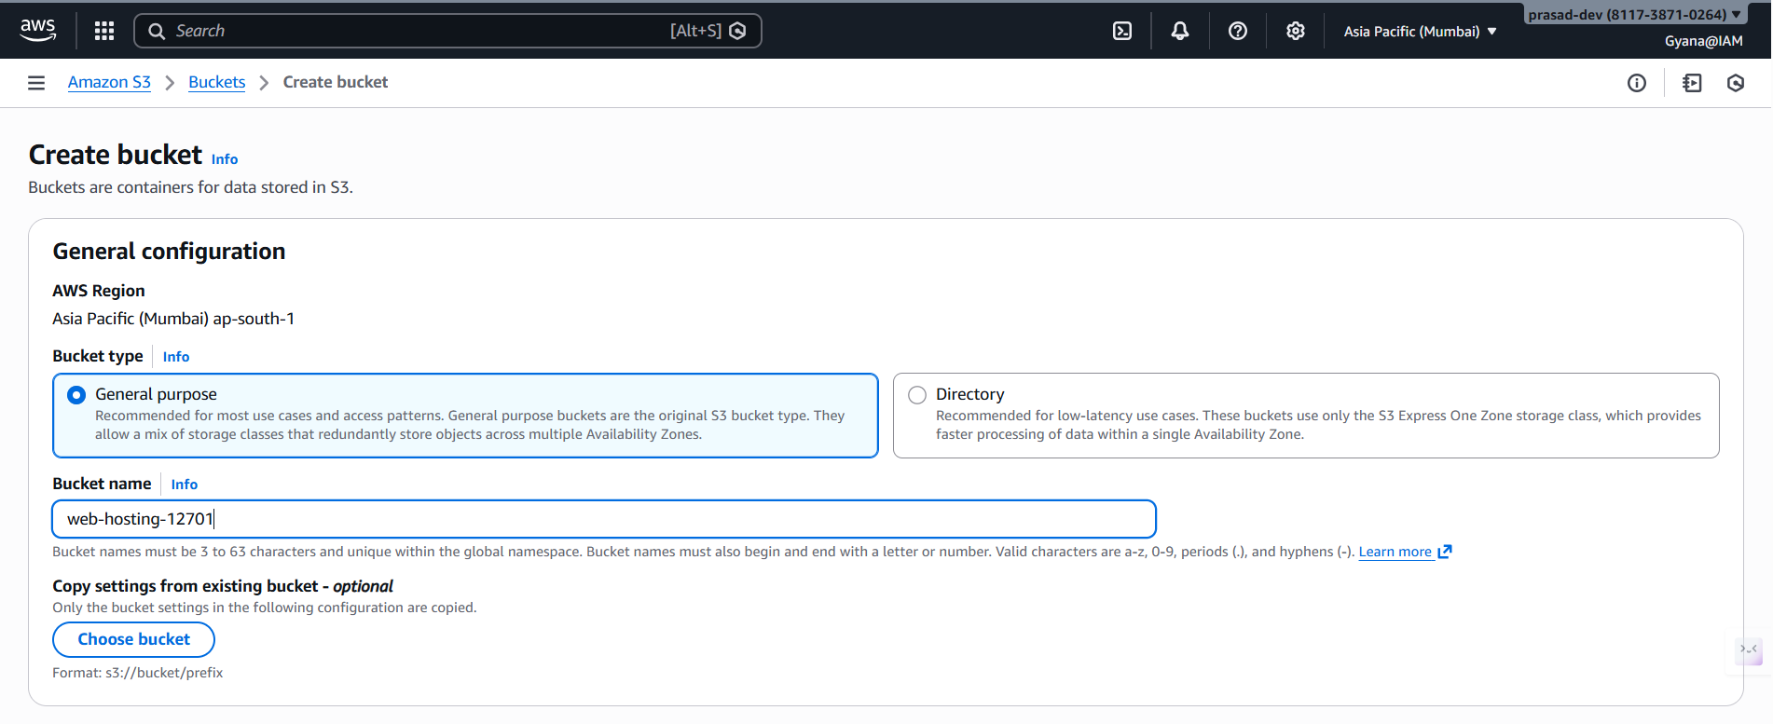
-Enabling the ACLs permission.
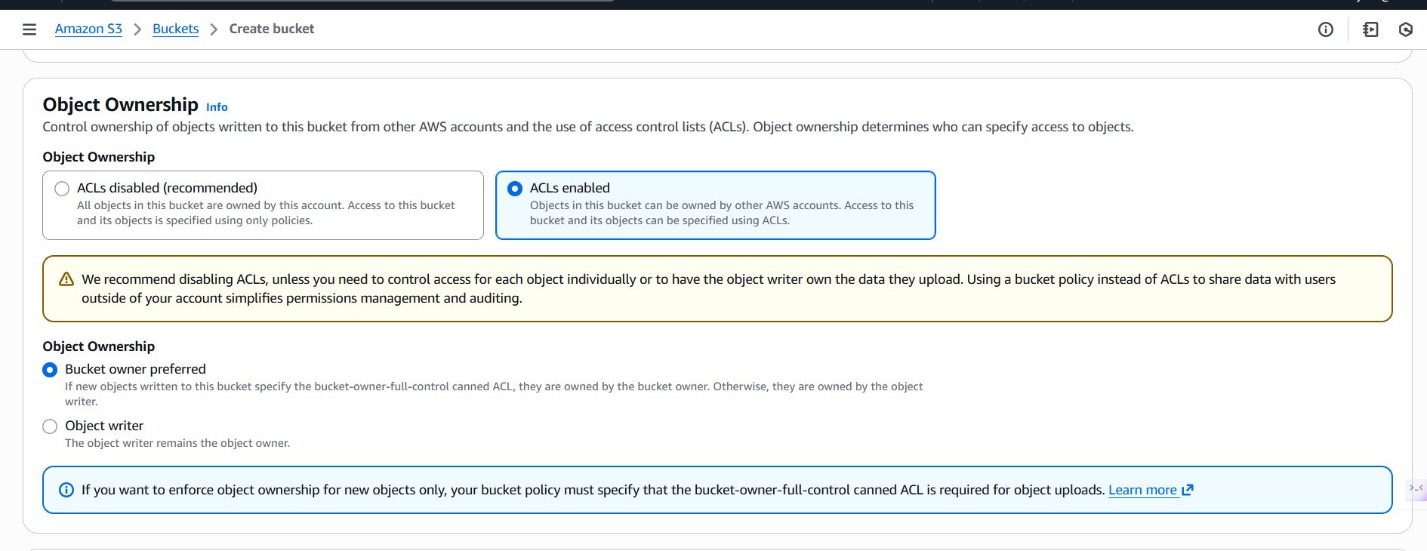

-Unchecking the Block all public access to make the bucket public.
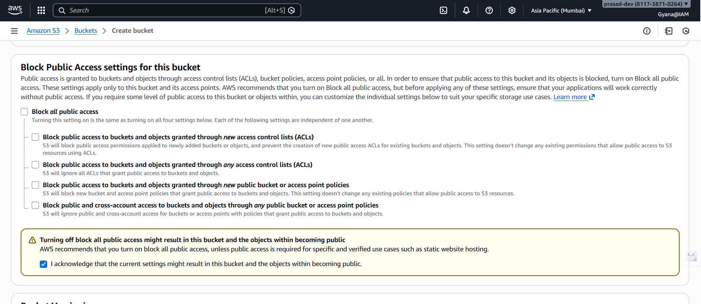
-Create the bucket,
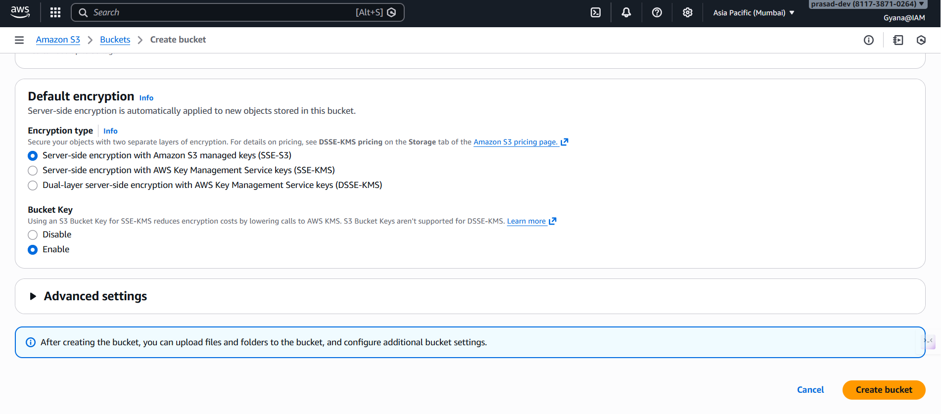
Bucket has be created.
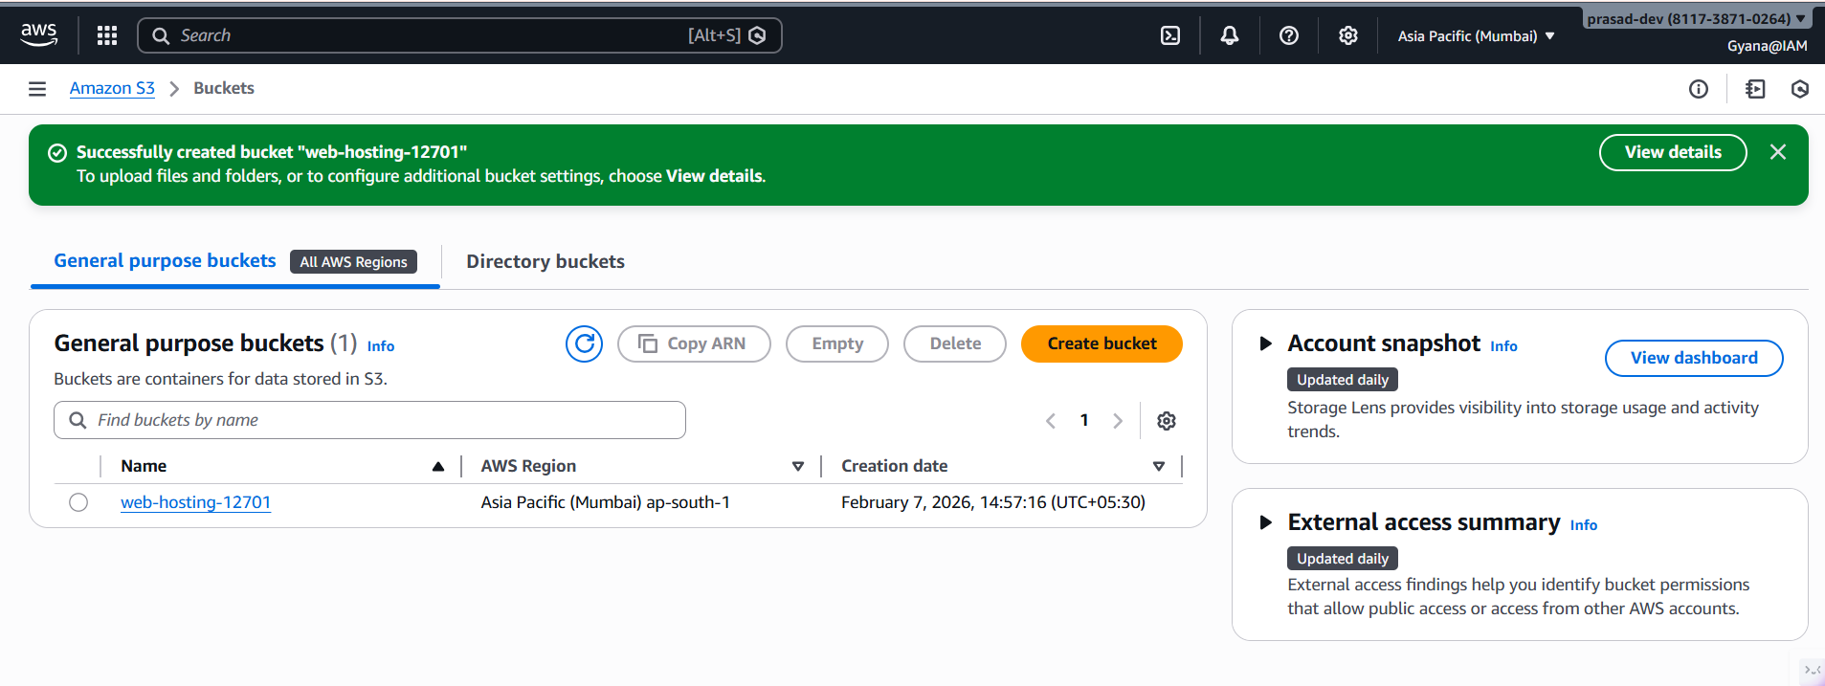

STEP-2
Now create folder in the local machine(windows/mac) and inside that folder create to files name index.html and error.html.
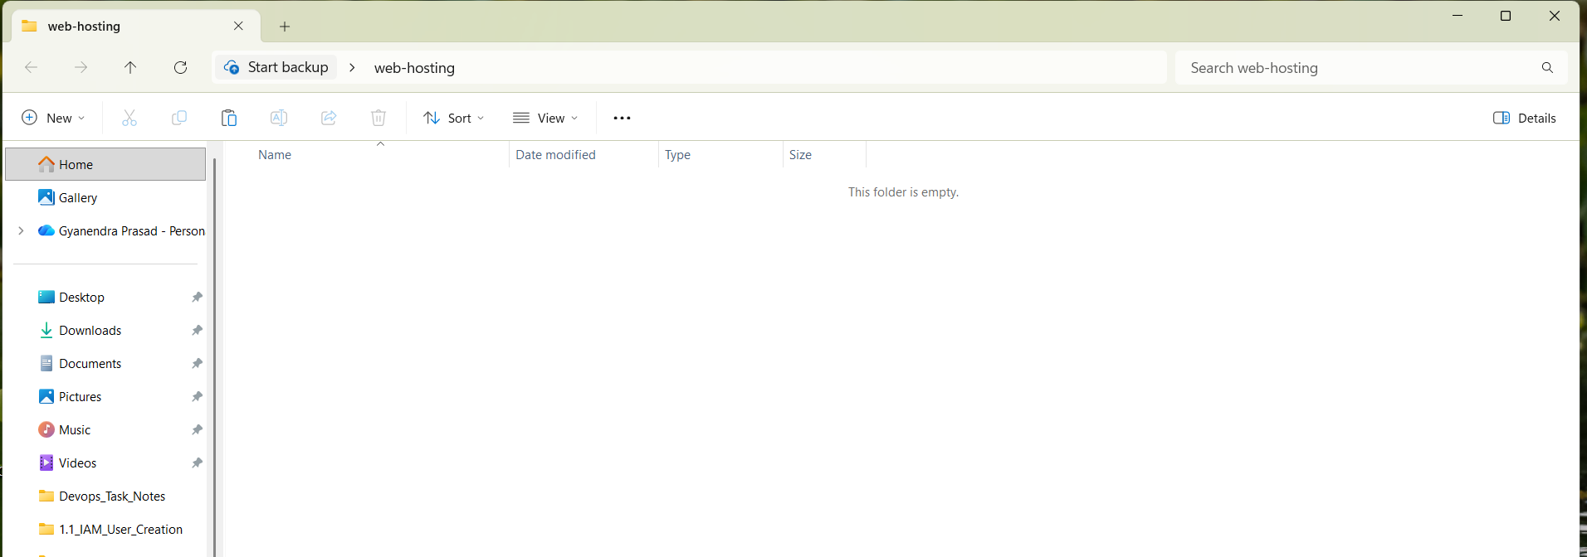
Index.html and error.html files contain the website codes and error message codes.
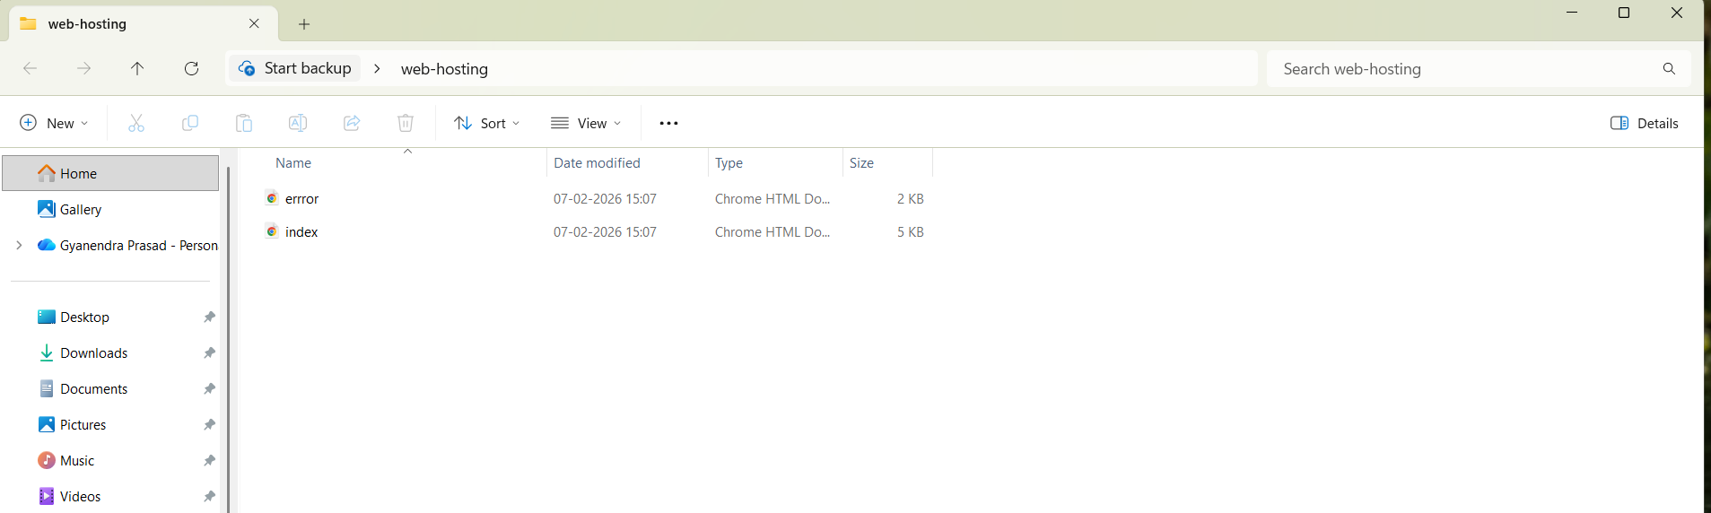

STEP-3
Now go inside the web-hosting-12701 bucket and click upload to upload the index.html and error.html files.
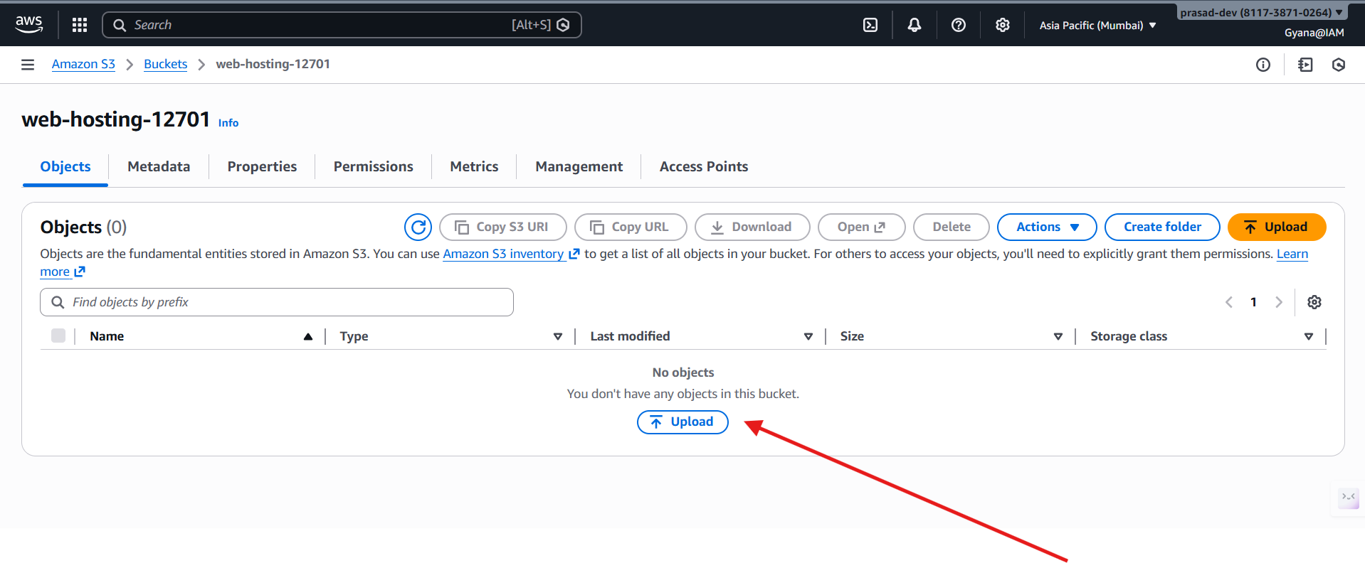
You can add direct files or can add folders directly.
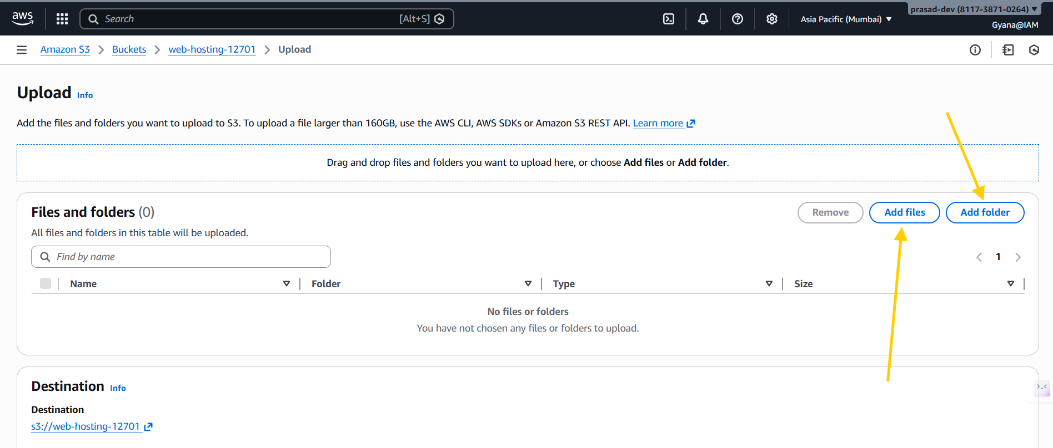
-Uploading the files
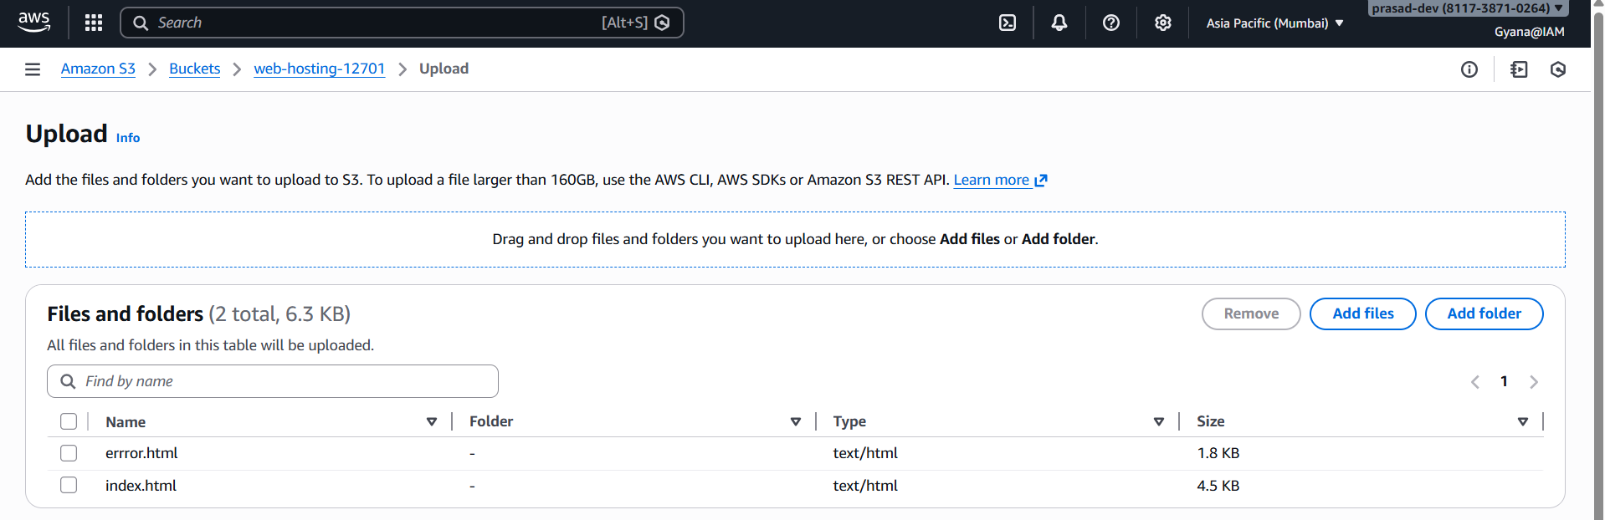

- Inside the Permissions section under the ACL, enable the public-read access of ACL to make the object for public access.
- By default it will be Private.
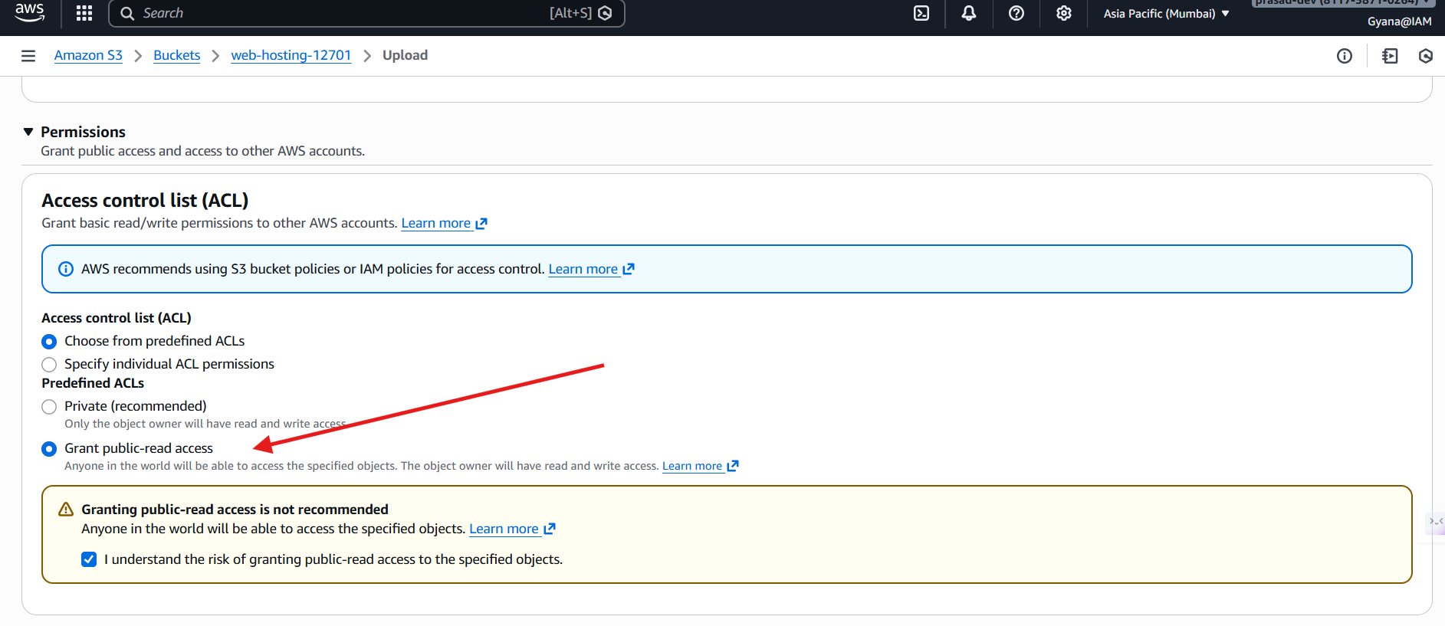
- Upload the files
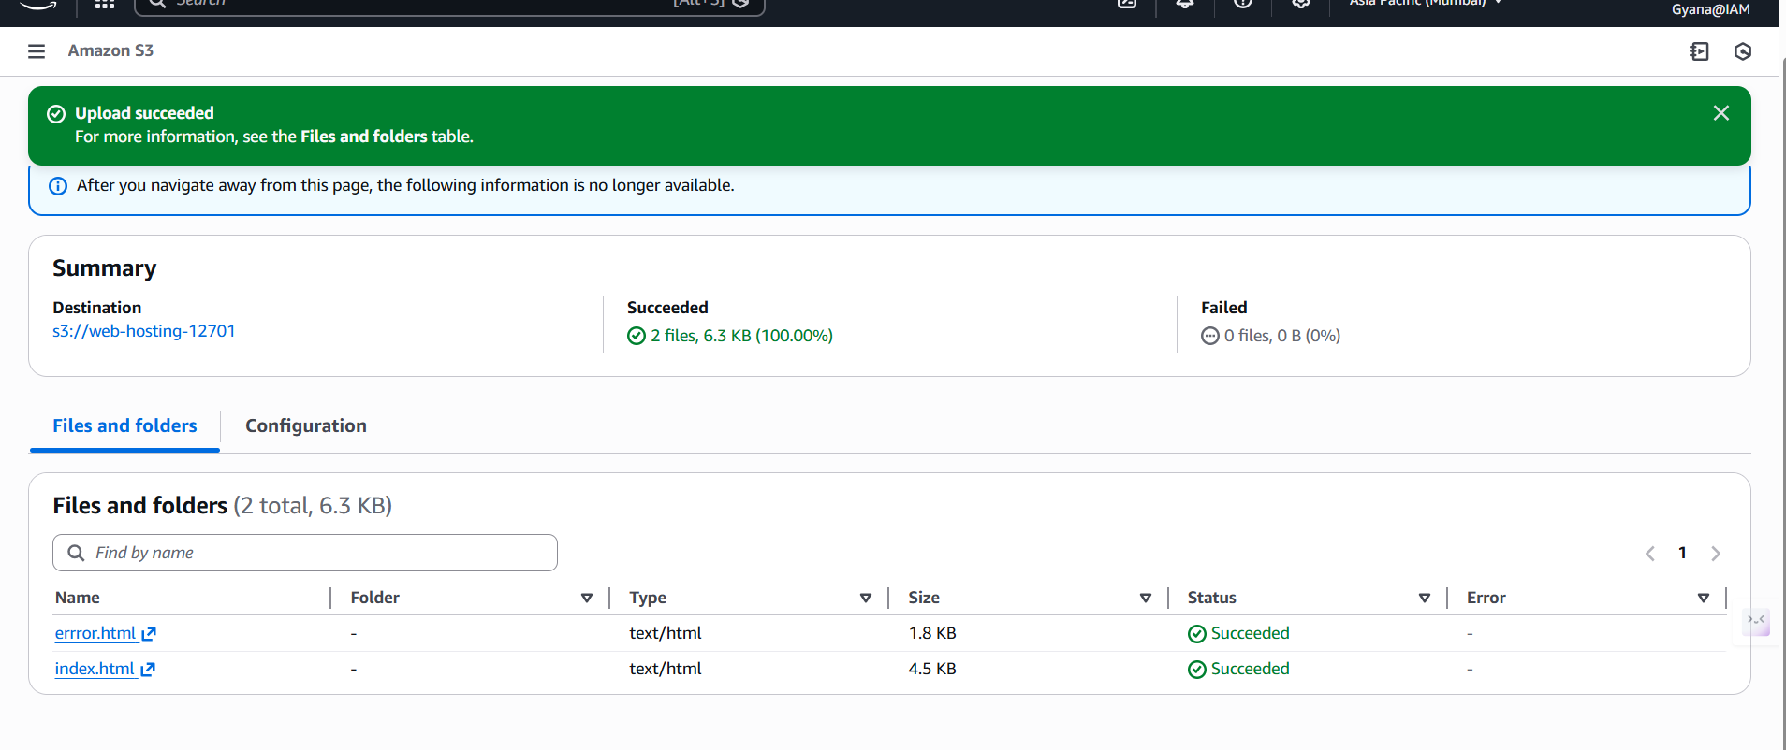
- After uploading the files go inside the Properties section to create end point url.

STEP-4
- End Point url creation.
- Go inside the Properties Section.
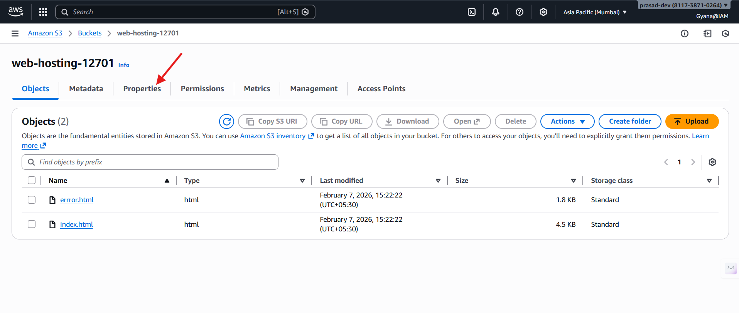
- Inside the Properties scroll down to Static Website Hosting.
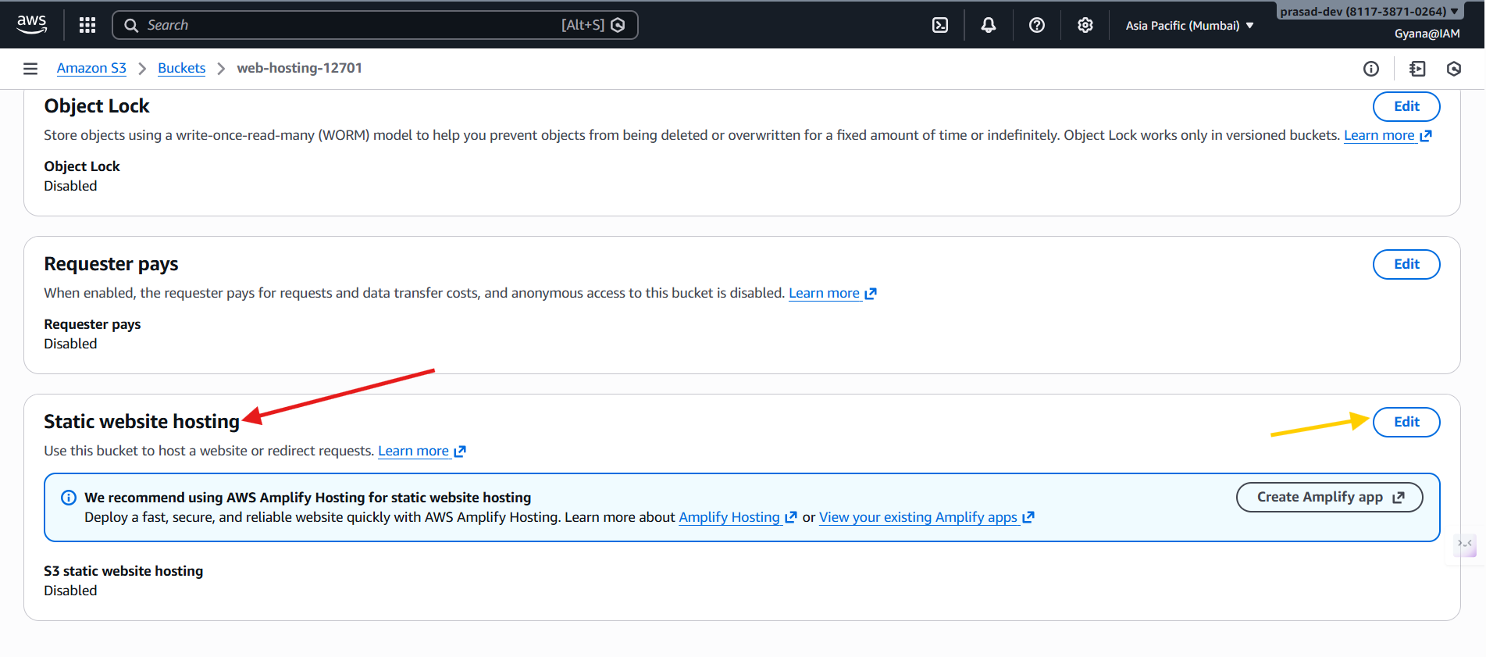

- Now Edit this section to add the index.html and error.html files to create the endpoint usrl.

- Enable the Static website hosting as it will be private by default.
- Then add the index.html and error.html under Index Document section.
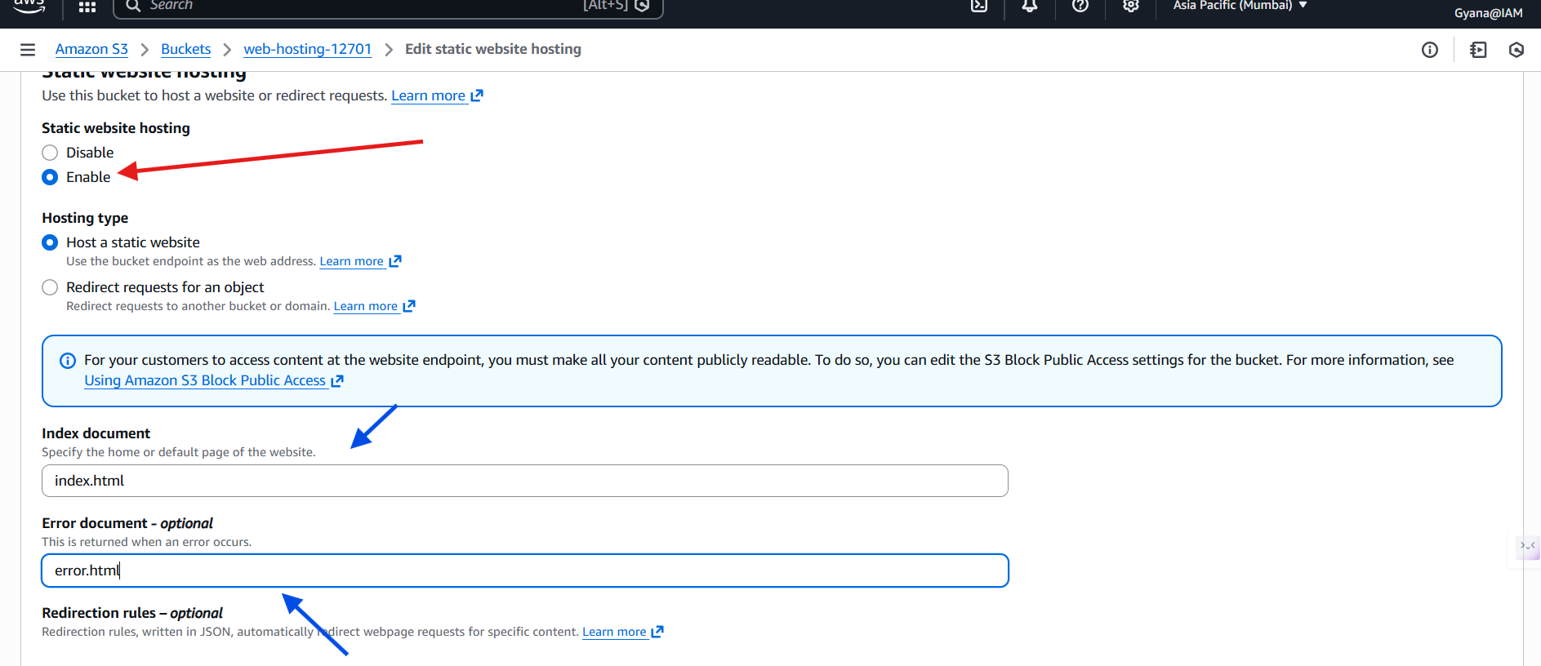
- Now save the changes and check the endpoint url for the object will be created.
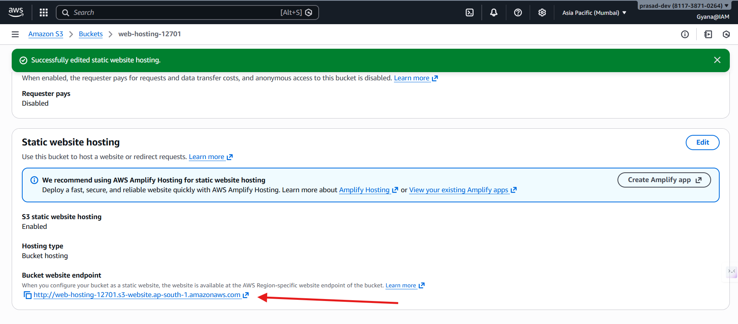
- Click the url to check the website.
- You can share the URL to others to check the website.

- Check the web site has been hosted.
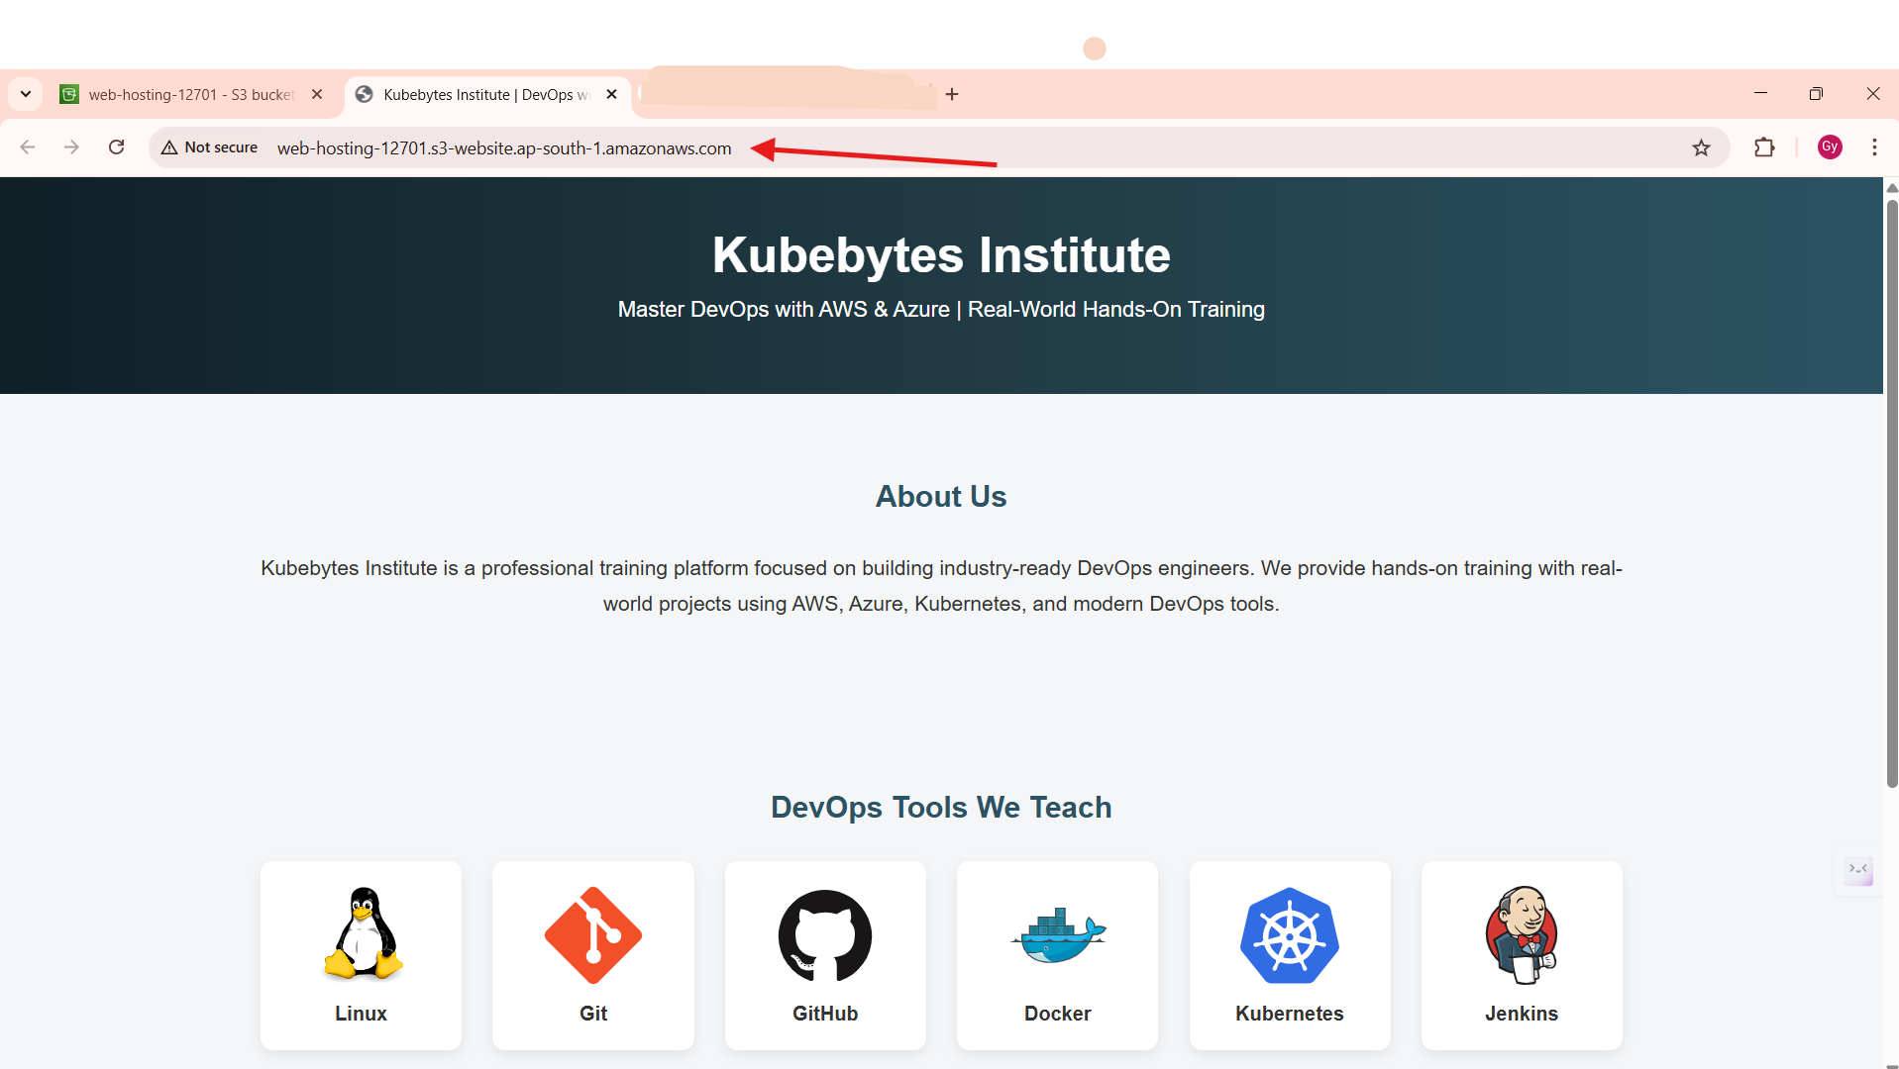

- If needed you can delete the bucket.
- But before deleting first empty the bucket first then can delete the bucket.
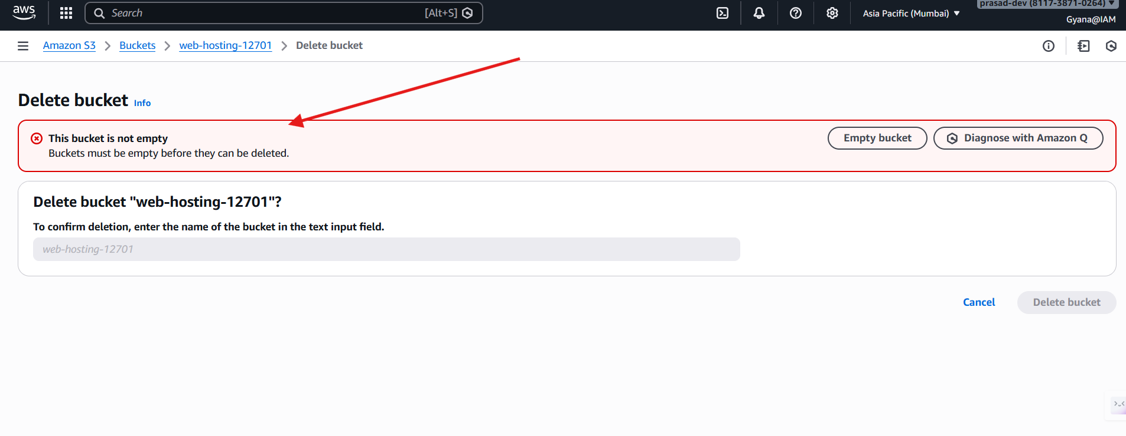
- We cant delete a bucket if it not empty.
- Delete the objects inside the buckets then delete the bucket.

Empty the bucket.
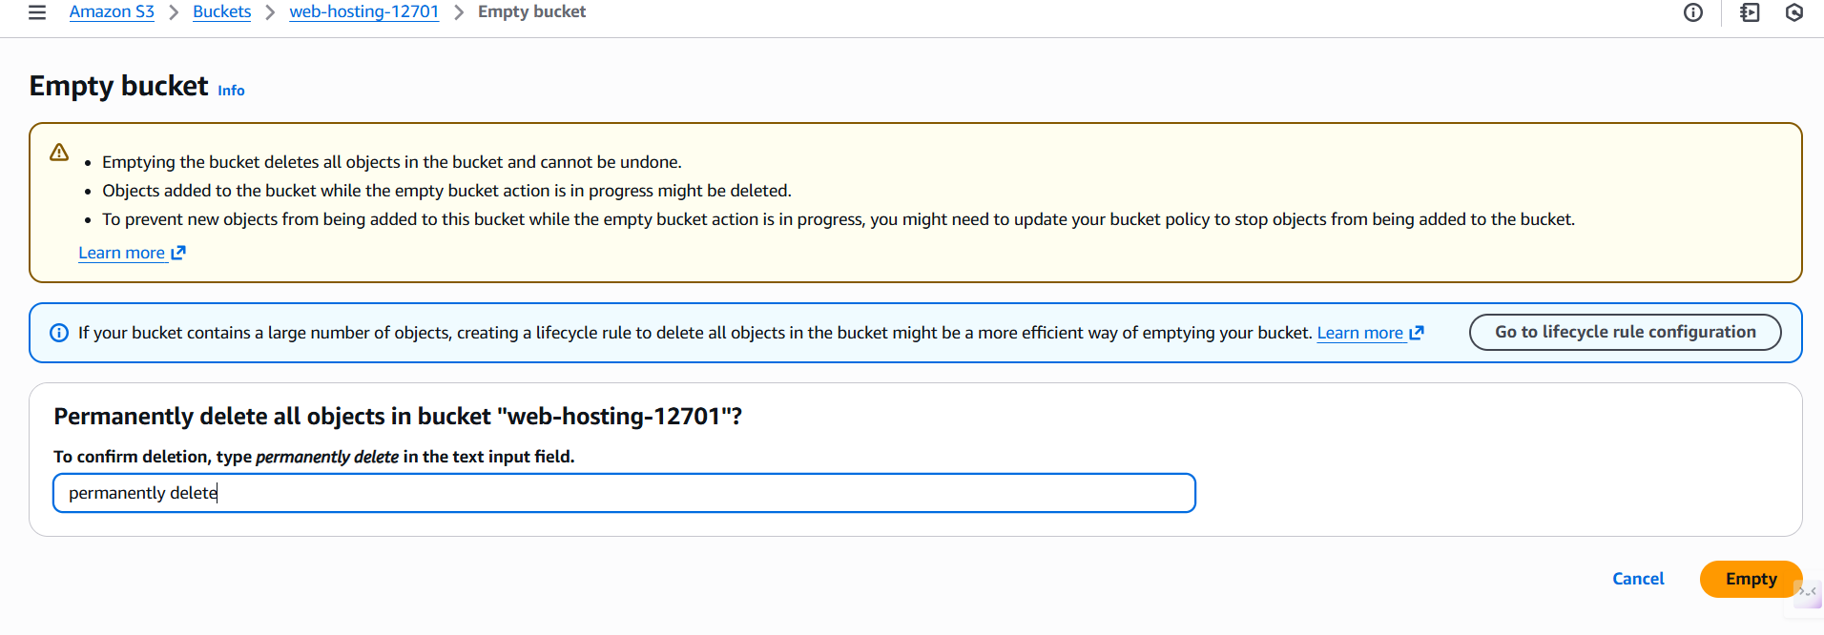
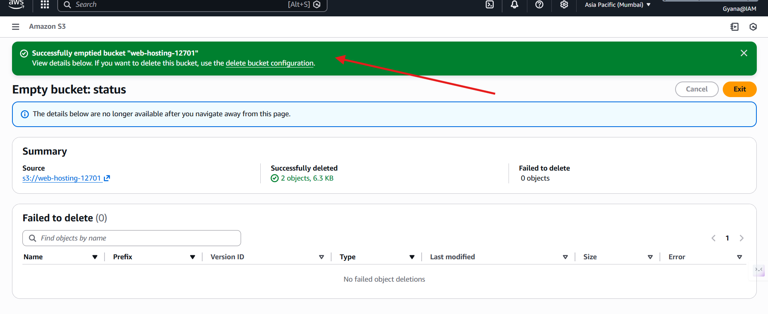
- Now will able to delete the bucket.
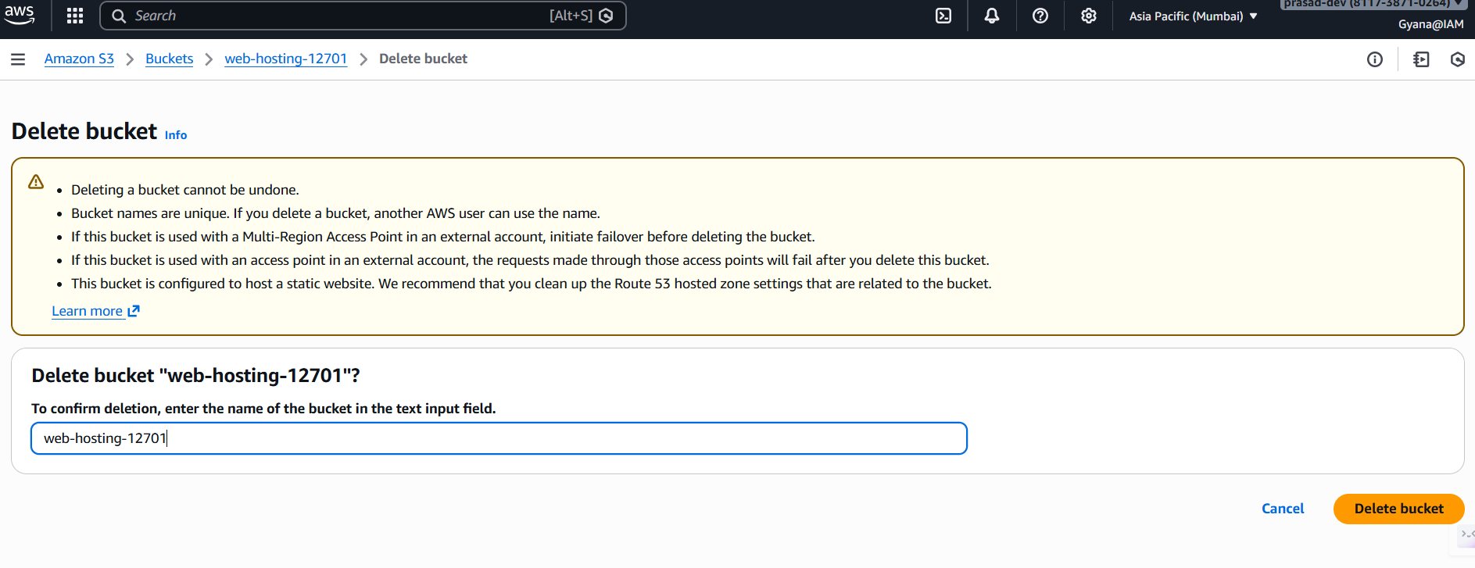- After deleting the bucket the web hosting will be closed.

